Software Requirements Specification
for
Railway Reservation System
Version 1.0 approved
Prepared by Adeel Yousafzai
COMSATS University Islamabad
07-11-2019
Table of Contents
Table of Contents ii
Revision History ii
1. Introduction 1
1.1 Purpose 1
1.2 Document Conventions 1
1.3 Intended Audience and Reading Suggestions 1
1.4 Product Scope 1
1.5 References 1
2. Overall Description 2
2.1 Product Perspective 2
2.2 Product Functions 2
2.3 User Classes and Characteristics 2
2.4 Operating Environment 2
2.5 Design and Implementation Constraints 2
2.6 User Documentation 2
2.7 Assumptions and Dependencies 3
3. External Interface Requirements 3
3.1 User Interfaces 3
3.2 Hardware Interfaces 3
3.3 Software Interfaces 3
3.4 Communications Interfaces 3
4. System Features 4
4.1 System Feature 1 4
5. Other Nonfunctional Requirements 4
5.1 Performance Requirements 4
5.2 Safety Requirements 5
5.3 Security Requirements 5
5.4 Software Quality Attributes 5
5.5 Business Rules 5
6. Other Requirements 5
Appendix A: Glossary 5
Appendix B: Analysis Models 5
Appendix C: To Be Determined List 6

Revision History
Name | Date | Reason For Changes | Version

Introduction
The project aims at development of Railway Reservation System which the Railway customers to manage their reservation online and the Railway admins to modify the backend database in a user-friendly manner. The Customer are required to register on the server for getting access to the database and query result retrieval.

Purpose
The Purpose of Railway Reservation System is to create Reservation, Cancel Reservation, to See Train detail, to see reservation information, editing or updating train detail, changing reservation details and generate outputs.

Document Conventions
- Main heading: Bold
- Not applicable

Intended Audience and Reading Suggestions
The different types of readers are as follow.
- Developers
- Train management
- Passengers
- Clerk and counter member

Product Scope
The aim of proposed system is to develop a system of improved facilities. The proposed system can overcome all the limitations of the existing systems. The system provides proper security and reduces the manual progress.

- Data is secured
- Data accuracy is confirmed.
- Minimizes manual data entering work.
- Efficiency increases.
- Good Service.
- User friendly and interactive.
- Minimum waste of time.

References
www.google.com
www.wikipedia.com
www.youtube.com
www.github.com
www.Quora.com

Overall Description

Product Perspective
It enables to control the railway reservation management and to enter and update data of the customer, employees, trains and ticket detail. It also enables us to book and cancel a ticket.

Product Functions
There are two different interfaces of the railway reservation system. One is the user interface which is for the guest and customer. The other is for administrator and management of the train.

User interface
- Sign up
- Sign in
- View Train detail
- Reserve ticket
- Cancel ticket
- Give payment

Admin interface
- Login
- File report
- Ticket Functions
- Reservation functions
- Edit/Check Pricing
- Access setting
- Members functions

User Classes and Characteristics
Educational Level: At least user of the system should be comfortable with English Language.

Technical Level: User should be comfortable using general purpose application on computer system.

Operating Environment
- Window 7
- Windows 8
- Windows 10

Design and Implementation Constraints
Software Constraints: The system should run on windows 7 and higher platform of operating systems
Design Constraints: It should be user friendly and there should be windows application and web based interface as well.

User Documentation
The user should be provided with proper tutorial videos and hints in the system built in for the new uses. There should be different links which will explain that how to use the system properly.

Assumptions and Dependencies

AS-1: Users of RRS are assumed to have a computer with internet access.

AS-2: Credit and debit card authorization services are assumed to be available.

DE-1: RRS has collaboration with every Railways database thus it must be able to communicate with these systems. Also, it must obey Railway business rules.

External Interface Requirements

User Interfaces

The system shall provide a help link from each displayed HTML page to explain how to use that page. The Web page of RRS shall permit complete navigation, train selection, ticket reservation and ticket/train information query view using keyboard and mouse combinations.

Hardware Interfaces
No specific Hardware interface for the Train Reservation System.

Software Interfaces
The database system should store and retrieve all properties like departure time, train number, timing, ticket number, customer number, seat, destination etc. It should also store the availability of train and the other details of it whether requested reservation is available or not. The database system should accept information and update the work flow. It should provide any valid request by user or admin.

Communications Interfaces
- Broadband Internet.
- SMS.
- Telephone.

System Features

System Feature 1
4.1.1 Description and Priority
The search feature allows the user to search for any destination.
4.1.3 Functional Requirements
Req# | Description | Priority
REQ-S1 |  | [Priority = High]
  Any error in entry of the system will stop the system from processing the search. An error message will be displayed to user.
REQ-S2 |  | [Priority = Medium]
  The user may specify anywhere from 1 to 10
  passengers.
REQ-S3 | The System Should be available 24/7 | [Priority = High]
REQ-S4 |  | [Priority = Medium]
  The standard train search method will allow the user to specify a preferred Railway.
REQ-S5 | The standard train search method will enable the user to search both exact dates and of arrival and departure dates. | [Priority = Medium]
REQ-S6 | Using the standard trains search method, the user shall be able to specify the departure and return date of the trains. | [Priority = High]
REQ-S7 | User should be able to search by Train number and railway. This will allow the user to see the specific train for the railway. | [Priority = Low]

Other Nonfunctional Requirements

Performance Requirements

PE-1: The system shall accommodate 1000 users during the peak usage time window of 8:00am to 10:00am local time.

PE-2: All Web pages generated by the system shall be fully downloadable in no more than 10 seconds over a 1Mb internet connection.

PE-3: The Should not take more than 10 secs to process a request.

PE-4: The system shall display confirmation messages to user in 2 secs.

Safety Requirements
The system shall disconnect all connections in case of cyber attack.

Security Requirements
- SE-1: Users shall be required to log in to the RRS for their own reservation information and modification with e-mail address and password.

- SE-2: The system shall permit only authorized members who are on the list of authorized Menu
Managers to do administrator’s task.

- SE-3: The system shall permit customers to view only their own previously placed orders, not orders placed by other customers.

Software Quality Attributes
Reliability
The database of the system should have automatic backup and recovery system. The reliability depends of many things but in this case database is important.

Usability
The interface of the system should be user friendly and in a language which the user of any country can understand. Adding multiple languages interface will solve the problem.

Maintainability
The system should be upgradeable if in future the we want to add new module it should be implemented easily. Like refreshment module.

Business Rules
The main business goal must be to maximize the profit and make the system efficient.
The system should allow as many users as possible to maximize the profit.
The bill should be passed under train reservation system in order to implement any changes

Other Requirements
There should be Food and other refreshment ordering module for the customers
Appendix A: Glossary
ABS: Automatic block system.
Base Case: see capacity or capacity analysis.
Bulk train: see train and traffic type.
Appendix B: Analysis Models
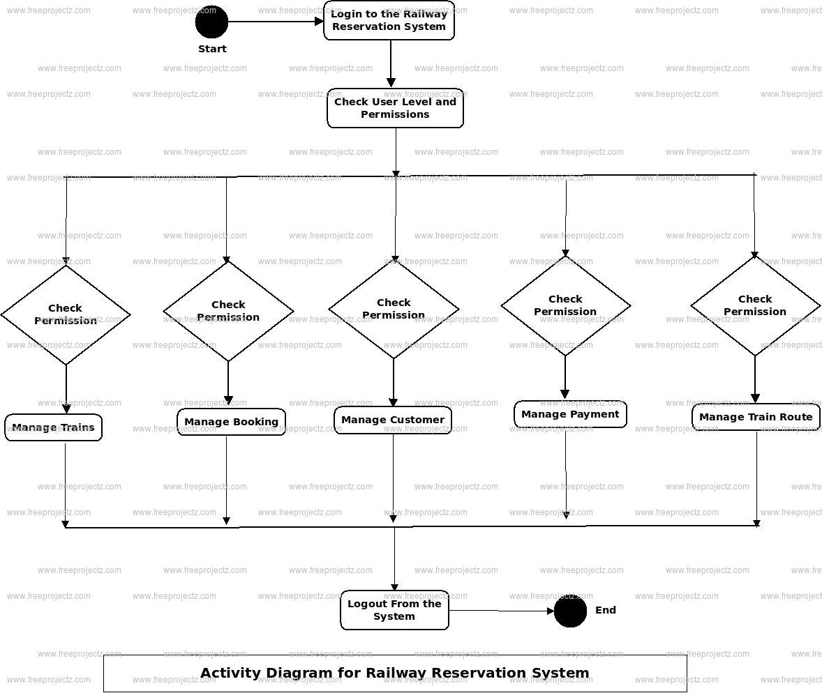Appendix C: To Be Determined List
No specific References.

